EECE.5862 – Embedded Artificial Intelligence

Lab 2 – Track W

Student
Himadri Saha

Objective

This lab covered the full embedded ML pipeline: collecting live temperature and humidity data from the Arduino Nano 33 BLE Sense Rev2, training a TinyML snowfall classifier off-device, deploying the quantized model back onto the board, and measuring its accuracy and inference latency.

Part A – Temperature and Humidity Data Capture
Environmental data was collected using the HS3003 sensor on the Arduino Nano 33 BLE Sense Rev2. A custom sketch sampled temperature and humidity once per second, streaming each reading over Serial as a CSV line containing elapsed time (ms), temperature (°C), and relative humidity (%).

Part B – Model Training and Deployment
The provided Colab notebook was run to train a snowfall classifier, exporting the result as model.cpp for deployment on the Arduino. The required modification changed the feature window length (kWindowLen) from 3 to 6. After retraining, the float32 model reached 85.65% validation accuracy. Following INT8 quantization, accuracy held at 85.99% with a final model size of 3,160 bytes.
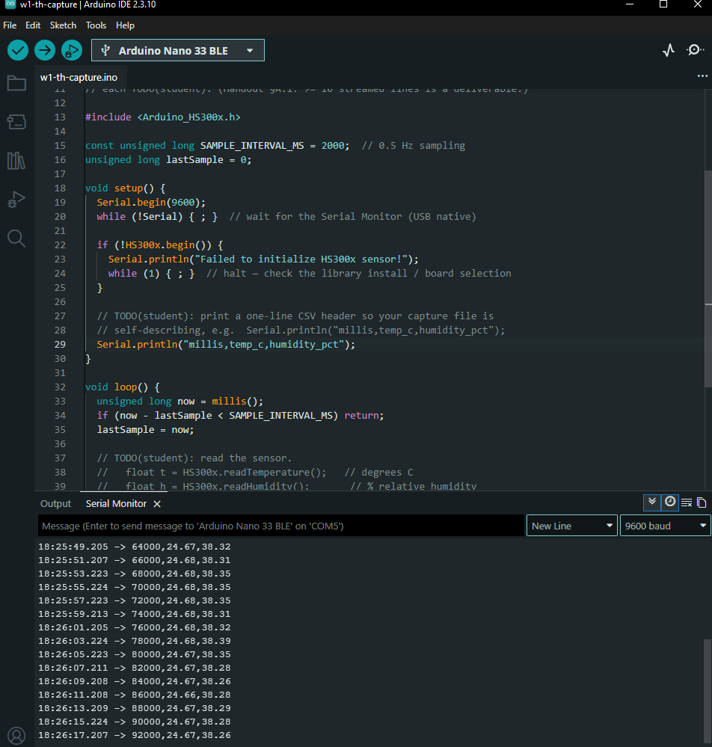

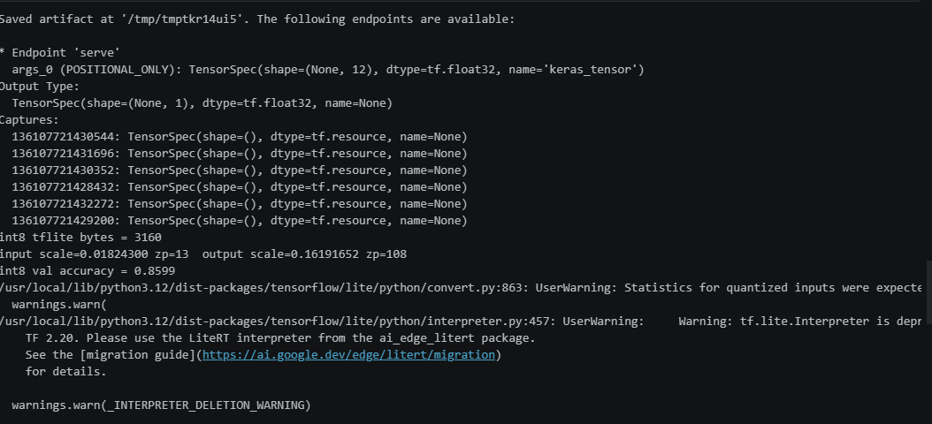

Part C – On-Device Inference and Performance Evaluation
The exported model was deployed to the Nano 33 BLE Sense Rev2 using TensorFlow Lite for Microcontrollers. Live temperature and humidity readings were normalized, quantized, and fed into the model for inference, with predictions printed to the Serial Monitor and reflected on the built-in LED. 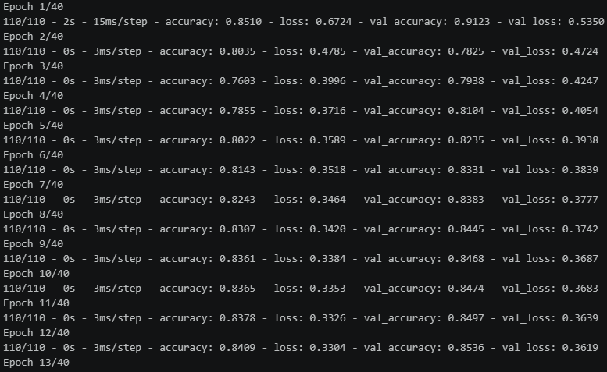

Example output:
temp_c=24.15, humidity_pct=46.30, p_snow=-17.8042, prediction=NO SNOW
Latency results
Minimum latency: 108 µs
Average latency: 109 µs
Maximum latency: 111 µs
Program storage: 134,128 bytes
Dynamic memory: 54,592 bytes

Discussion

Extending the feature window from 3 to 6 increased the amount of historical sensor data available per prediction. The float32 model achieved 85.65% validation accuracy after retraining, while the INT8-quantized model reached 85.99% at a significantly reduced memory footprint. Successful deployment to the Nano 33 BLE Sense Rev2 confirmed that the TFLM runtime can sustain low-latency inference on embedded hardware with limited compute and memory resources.

Conclusion
This lab demonstrated each stage of the embedded ML workflow: sensor data acquisition, off-device model training, INT8 quantization, deployment via TFLM, and real-time inference on the Arduino Nano 33 BLE Sense Rev2. The final weather classification model maintained high validation accuracy while achieving an on-device inference latency of approximately 109 µs, illustrating the practicality of TinyML on resource-constrained hardware.

